# Exercise: Files and Streams

This document defines the **exercises** for the ["Java Advanced" course @ Software University](https://softuni.bg/courses/java-advanced). Please submit your solutions (source code) of all below described problems in [Judge](https://judge.softuni.bg/).

## Sum Lines

Write a program that reads a text file and prints on the console the sum of the ASCII symbols of each of its lines. Use BufferedReader in combination with FileReader.

### Examples

|  |  |
| --- | --- |
| **Input** | **Output** |
| On January 1 , 1533 ,  Michael Angelo,  then fifty-seven years old,  writes  from Florence to  Tommaso de' Cavalieri,  a youth of noble Roman family, | 1452  1397  2606  670  1573  2028  2762 |
| Two households,  both alike in dignity, In fair Verona,  where we lay our scene, From ancient grudge  break to new mutiny | 1508  2062  1360  2125  1876  1848 |

### Hints

* Use try-with-resources to handle file

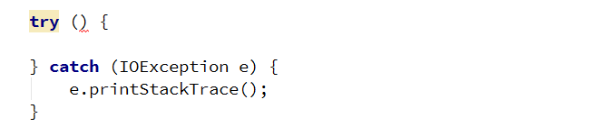

* Create a BufferedReader to read each line of the file

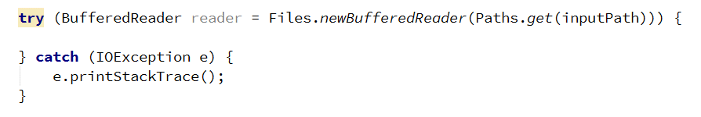

* Get the ASCII code of each character in the line and add it to the sum for the current line and print the sum on the console

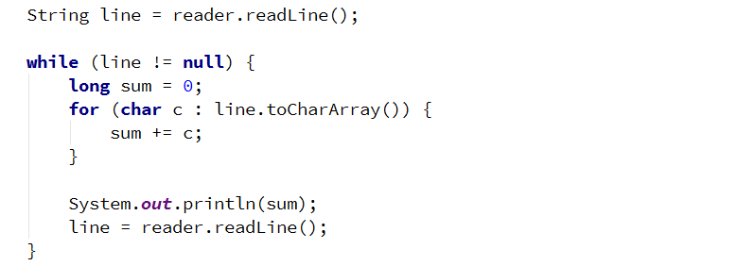

## Sum Bytes

Write a program that reads a text file and prints on the console the sum of the ASCII symbols of all characters inside of the file. Use BufferedReader in combination with FileReader.

|  |  |
| --- | --- |
| **Input** | **Output** |
| On January 1 , 1533 ,  Michael Angelo,  then fifty-seven years old,  writes  from Florence to  Tommaso de' Cavalieri,  a youth of noble Roman family, | 12488 |
| Two households,  both alike in dignity, In fair Verona,  where we lay our scene, From ancient grudge  break to new mutiny | 10779 |

### Hints

* You can modify your solution to the previous problem
* Use a type that will not overflow like long or BigInteger

## ALL CAPITALS!

Write a program that reads a text file and changes the casing of all letters to upper. Write the output to another file.

### Examples

|  |  |
| --- | --- |
| **Input** | **Output** |
| On January 1 , 1533 , Michael Angelo, then fifty-seven years old, writes  from Florence to Tommaso de' Cavalieri, a youth of noble Roman family, | ON JANUARY 1 , 1533 , MICHAEL ANGELO, THEN FIFTY-SEVEN YEARS OLD, WRITES  FROM FLORENCE TO TOMMASO DE' CAVALIERI, A YOUTH OF NOBLE ROMAN FAMILY, |
| who afterwards became his favourite pupil: "If I do not possess the  art of navigating the sea of your potent genius, that genius will | WHO AFTERWARDS BECAME HIS FAVOURITE PUPIL: "IF I DO NOT POSSESS THE  ART OF NAVIGATING THE SEA OF YOUR POTENT GENIUS, THAT GENIUS WILL |

### Hints

* Use BufferedReader andPrintWriter.

## Count Character Types

Write a program that reads a list of words from the file **input.txt** and finds the count of vowels, consonants and punctuation marks. Assume that:

* **a, e, i, o, u** are vowels
* All others are consonants
* Punctuation marks are (**!,.?**)
* Do not count whitespace.

Write the results to another file.

### Examples

|  |  |
| --- | --- |
| **Input** | **Output** |
| Thanks to us, you owe it to the Chinese. | Vowels: 13  Consonants: 17  Punctuation: 2 |

### Hints

* Use BufferedReader andPrintWriter.

## Line Numbers

Write a program that reads a text file and inserts line numbers in front of each of its lines. The result should be written to another text file.

### Examples

|  |  |
| --- | --- |
| **Input** | **Output** |
| Two households, both alike in dignity,  In fair Verona, where we lay our scene,  From ancient grudge break to new,  Where civil blood makes civil hands.  From forth the fatal loins of these two  A pair of star-cross'd lovers take their life;  Whose misadventured piteous overthrows  Do with their death bury their parents' strife. | 1. Two households, both alike in dignity,  2. In fair Verona, where we lay our scene,  3. From ancient grudge break to new,  4. Where civil blood makes civil hands.  5. From forth the fatal loins of these two  6. A pair of star-cross'd lovers take their life;  7. Whose misadventured piteous overthrows  8. Do with their death bury their parents' strife. |

## Word Count

Write a program that reads a list of words from the file words.txt and finds how many times each of the words is contained in another file text.txt. Matching should be case-insensitive.

Write the results in file results.txt. Sort the words by frequency in descending order.

|  |  |
| --- | --- |
| **Input** | **Output** |
| Two thou shall see | Two - 30  shall - 22  thou - 19  see - 13 |

## Merge Two Files

Write a program that reads the contents of two text files and merges them together into a third one.

|  |  |  |
| --- | --- | --- |
| **File 1** | **File 2** | **Output** |
| 1  2  3 | 4  5  6 | 1  2  3  4  5  6 |

## Get Folder Size

Write a program that traverses a folder and calculates its size in bytes.

|  |  |
| --- | --- |
| **Input** | **Output** |
|  | Folder size: 486 |

## Copy a Picture

Write a program that makes a copy of a **.jpg** file using FileInputStream, FileOutputStream, and byte[] buffer. Set the name of the new file as **picture-copy.jpg**.

## Serialize Array List

Write a program that saves and loads an ArrayList of doubles to a file using **ObjectInputStream** and **ObjectOutputStream**. Set the name of the file as list.ser**.**

## *Serialize Custom Object

Write a program that saves and loads the information about a custom object using **ObjectInputStream** and **ObjectOutputStream**.

Create a **simple** **class** called "Course" that has a **String field** containing its **name** and an **integer field** containing the **number of students** attending the course. Set the name of the save file as course.ser**.**

## *Create Zip Archive

Write a program that reads three **.txt** files and creates a zip archive named **files.zip.** Use FileOutputStream, ZipOutputStream, and FileInputStream**.**